10/06/2026
Final Lab Exam
Computer Network
Air University Aerospace and Aviation Campus Kamra

Submitted to: Sir Mansoor
Submitted by: Wasif Ali
Reg Id : 245187
Class : BSCS F’24-B
Task 02:

VLAN 10 Laptop 0 to Laptop 3
VLAN 20 Laptop 4 to Laptop 7
VLAN 30 Laptop 8 to Laptop 11
Same VLAN Can communicate cross VLAN Cannot communicate.
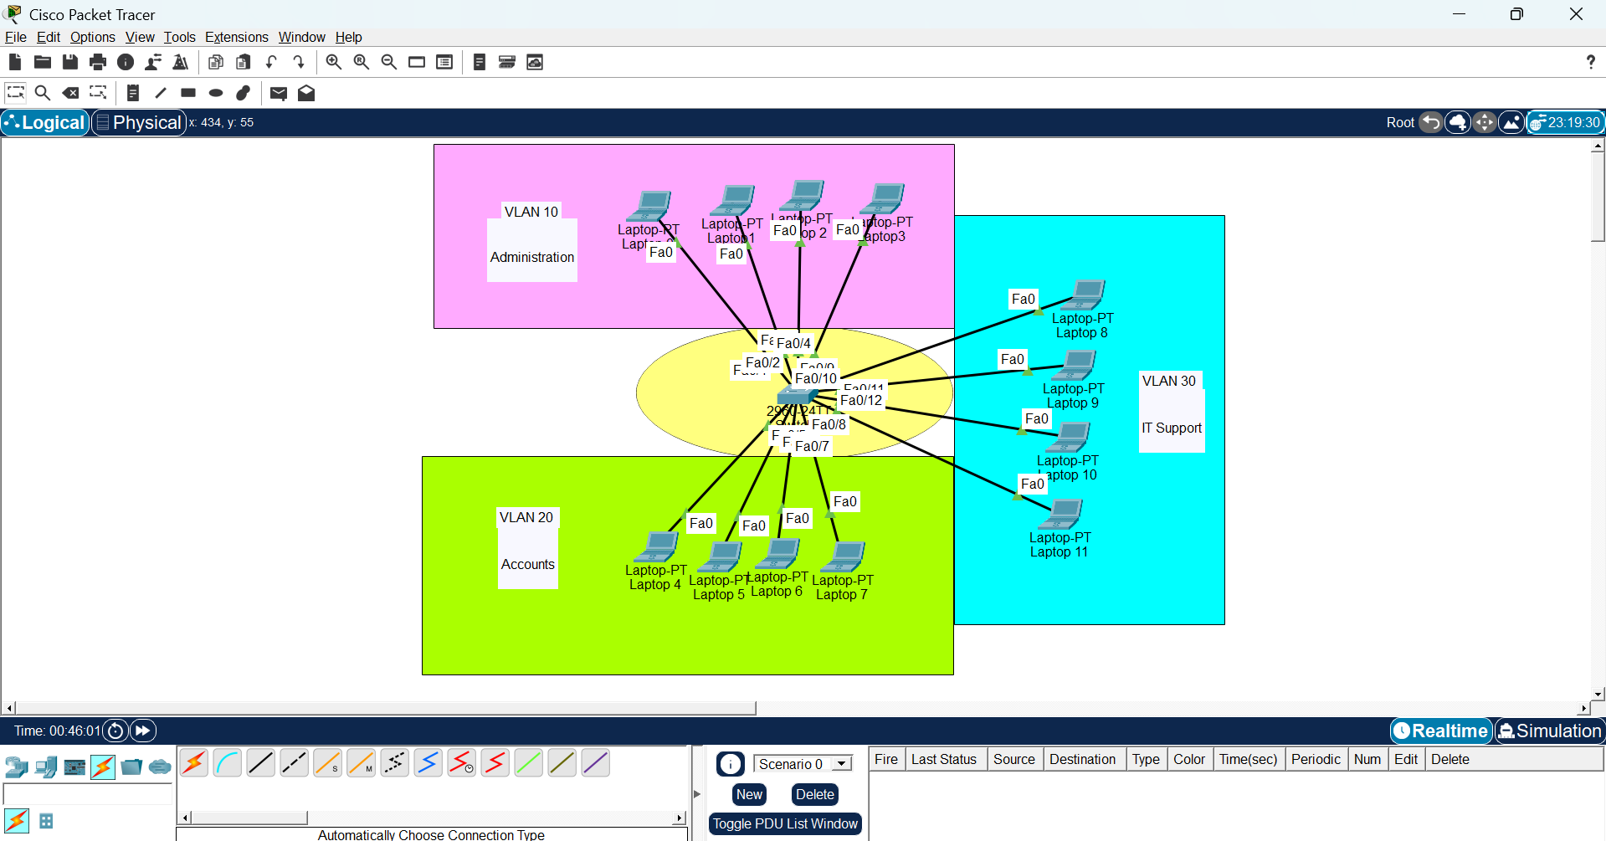
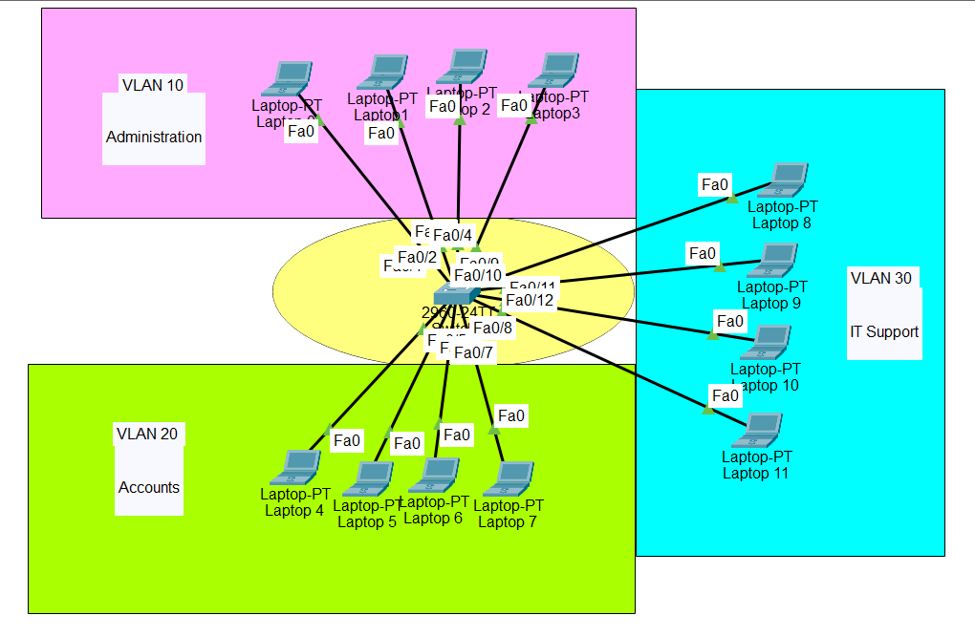

ALL CLI COMMANDS:
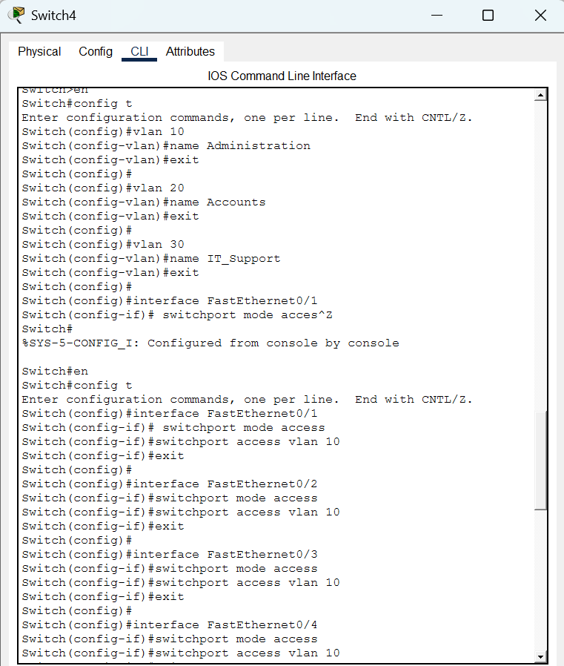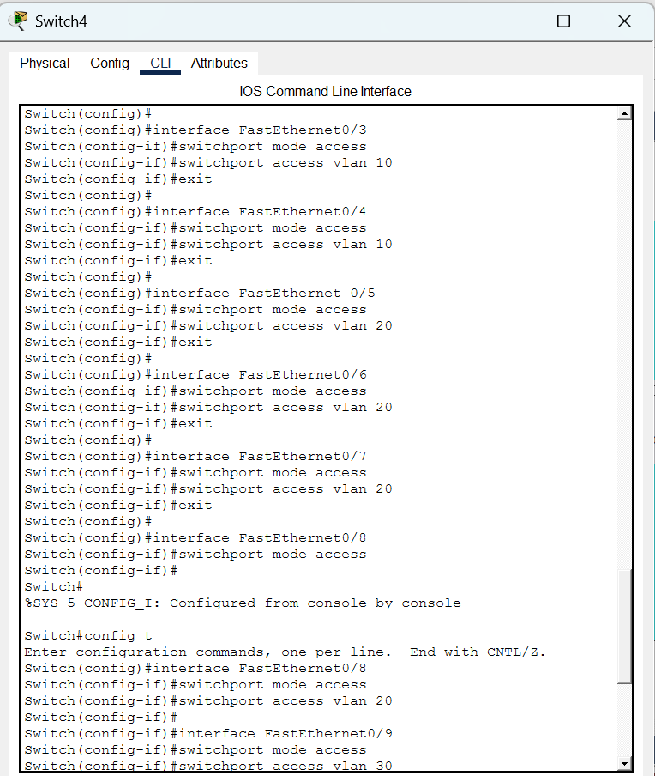

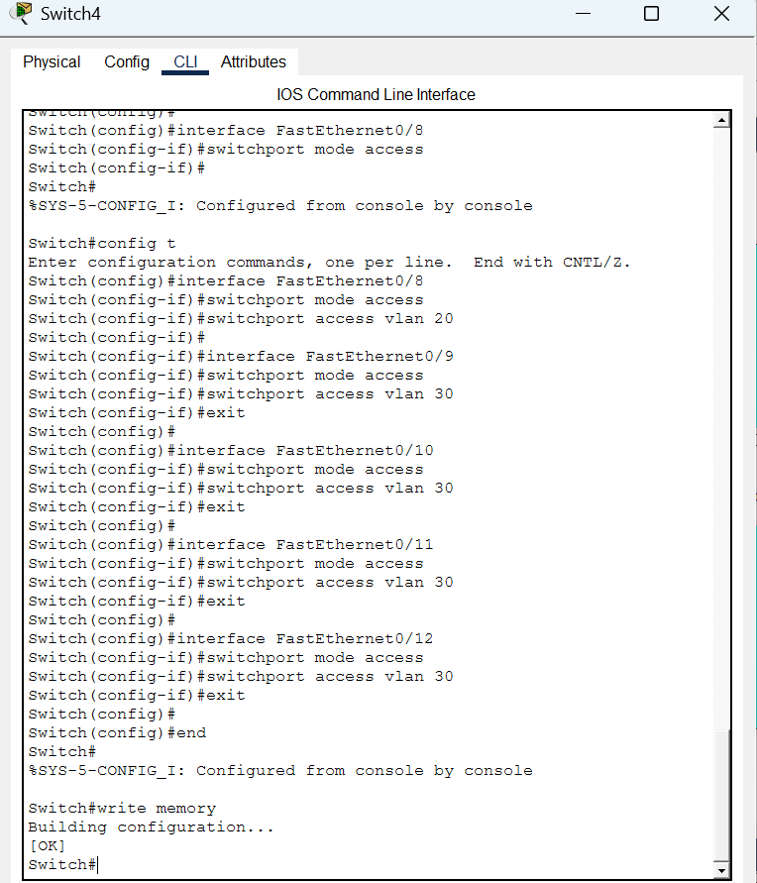

Check:

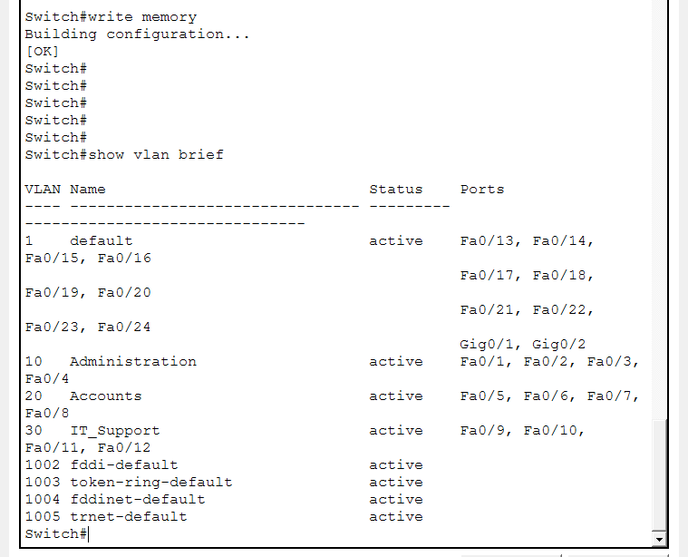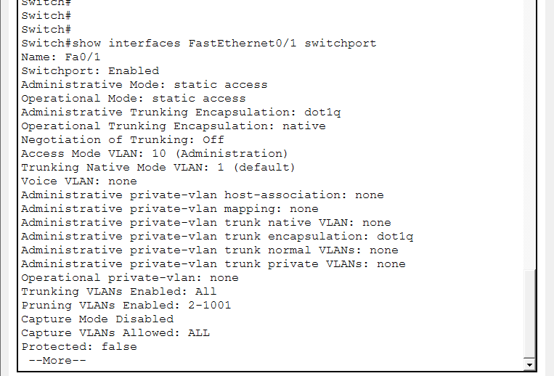
Proof Of Implementation:
CMD of VLAN 10
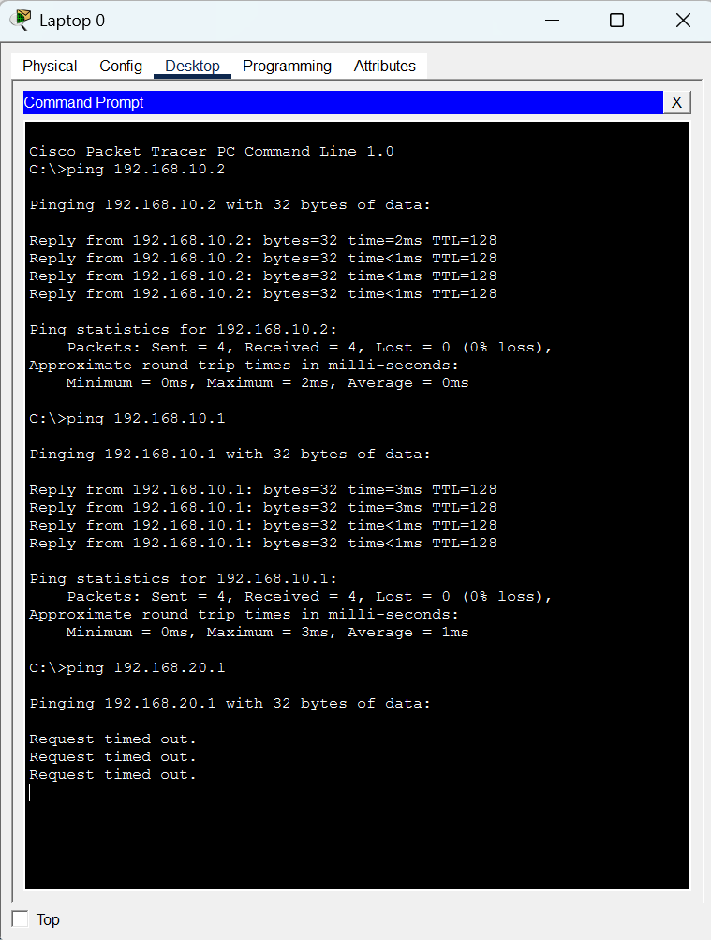
VLAN 10 can communicate within VLAN 10

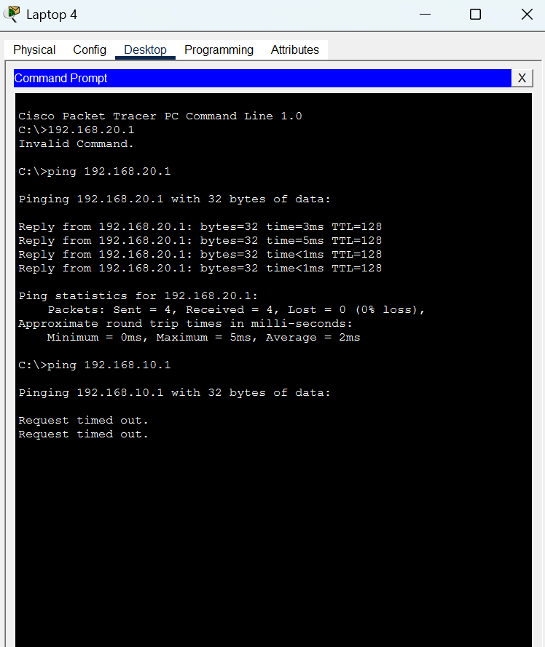
Cross VLAN Communication is restricted
VLAN 10 cant communicate with VLAN 20

TASK 01
